PETE 645 Project Report

Upscaling of Geologic Models for

Flow Simulation

Sengupta, Soumyadipta

Kotb, Abdel Rahman

Zhou, Yuhai

Sun, Jianlei  
Crouch, Spencer

Date: 12/3/2013

Contents

1. Executive Summary 3

2. 3D Pressure Solver for the flux 4

3. 3D Flow Visualization given the flux 5

4. Analytical Approaches 6

4.1 Arithmetic 6

4.1.1 Permeability Kx 6

4.1.2 Permeability Kz 6

4.1.3 Porosity 6

4.2 Harmonic 7

4.2.1 Permeability Kx 7

4.2.2 Permeability Kz 7

4.3 Geometric 7

4.3.1 Permeability Kx 7

4.3.2 Permeability Kz 8

4.4 Arithmetic-Harmonic 8

4.4.1 Permeability Kx 8

4.4.2 Permeability Kz 8

4.5 Harmonic-Arithmetic 9

4.5.1 Permeability Kx 9

4.5.2 Permeability Kz 9

4.6 Well Index Upscaling 9

4.6.1 Permeability Kx 9

4.6.2 Permeability Kz 9

4.7 Summary 10

5. Flow based Upscaling 10

6. Conclusions 11

7. References 12

# Executive Summary

**Model definition**

At the fine geological model scale, the model is described on a regular cartesian grid. The model dimensions are 1200 x 2200 x 170 (ft). The top 70 ft (35 layers) represents the Tarbert formation, and the bottom 100 ft (50 layers) represents Upper Ness. The fine scale cell size is 20 ft x 10 ft x 2 ft.

Four Producers at four corners at BHP=500 psi

One Injector at the centre at BHP=3000 psi

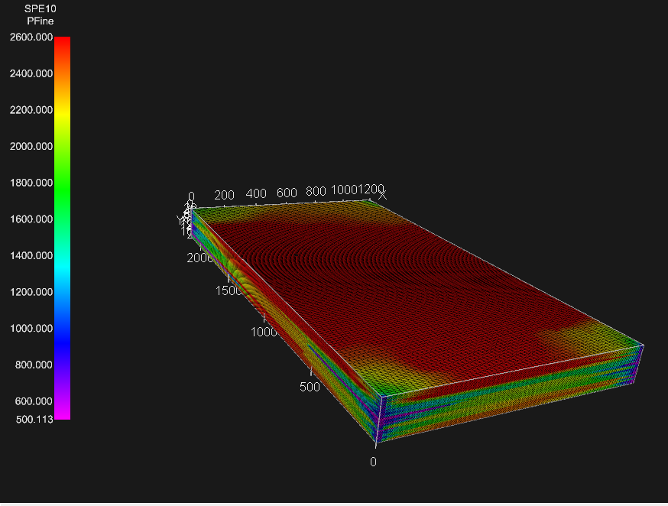

Pressure (fine scale)

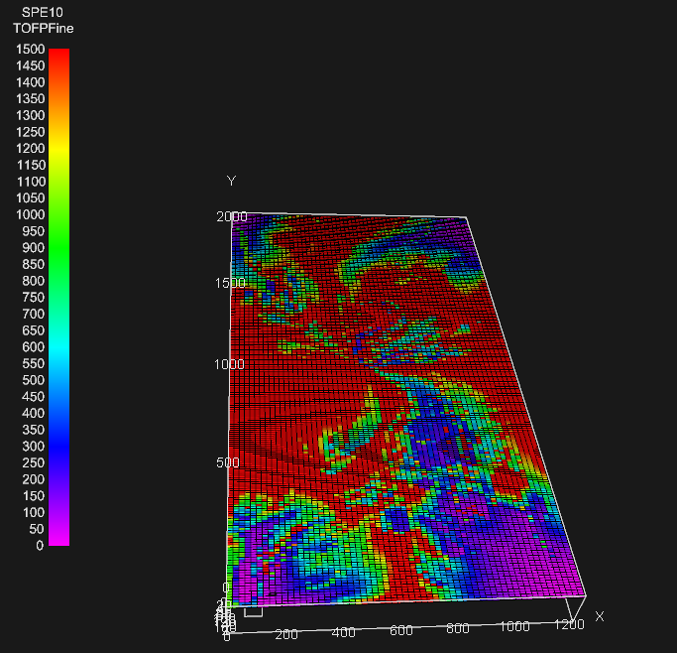 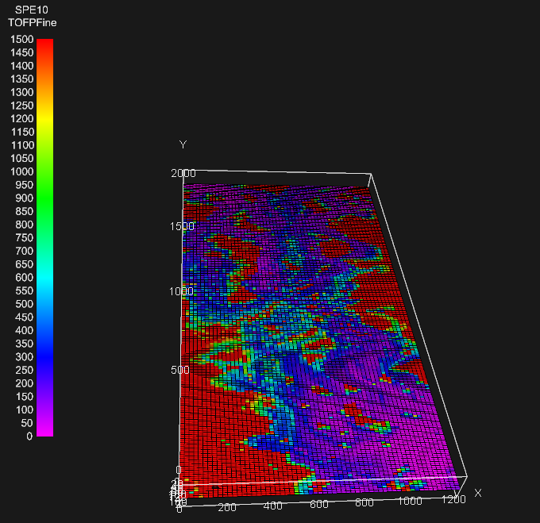

TOFP(fine scale)- Layer-5 TOFP(fine scale)-Layer-53

# 3D Pressure Solver for the flux

The pressure was solved on both the fine and the coarse grids.

Steps

* The fine cell properties were imported using our custom made program *GRDECL.m.*
* The Transmissibilities were calculated at the cell boundaries.
$$T=\frac{T1.T2}{T1+T2} , T1,T2-half cell transmsibilities of the adjoining cells$$

* The Transmissibility at the boundaries were zero because of no flow boundaries.
* The Transmissibility matrix would have seven diagonals in case of a 3-d pressure solver. These diagonals were evaluated.
* A sparse transmissibility matrix was formulated using the diagonals previously calculated.
* The pressure was solved using inbuilt sparse algebra in MATLAB.

Key points

* The fine model contained the injector in four cells in all the layers i.e. (110,31), (111,31), (110,30), (111,30). This means that the Peaceman correlation for these cells were
$$J_{model}=\frac{(\frac{π}{2})kh}{ln⁡(\frac{r_{o}}{r_{w}})}$$

* The 2x2x6 and 2x2x12 upscaling caused the injector to be in the following four coarse cells in every coarse layer i.e. (55,16), (55,15), (56,16), (56,15). The Peaceman correlation for these cells were $$J_{model}=\frac{(\frac{π}{2})kh}{ln⁡(\frac{r_{o}}{r_{w}})}$$
* The 4x4x6 upscaling caused the injector to be in (28, 8) coarse cell in each coarse layer. The complete Peaceman correlation was used for this and all the producers which were always in the corner cells.

$$J_{model}=\frac{2πkh}{ln⁡(\frac{r_{o}}{r_{w}})}$$

# 3D Time of Flight Solver

The fluxes are calculated for each cell interface. Pollock’s algorithm in dimensionless form is used to calculate the least time to reach a cell face.



The TOF calculation starts at the centre of a cell and it proceeds cell by cell until the streamline exits from the grid. This is the time of flight to the injector.

Then the flow fields are reversed and time of flight to the producer is calculated.

# Analytical Approaches

Analytical Approaches are used in this project to be compared with flow-based methods.

In total, we have six analytical methods and two upscaling schemes (2 by 2 by 6 and 4 by 4 by 6), which are discussed as follows:

## Arithmetic

## Permeability Kx

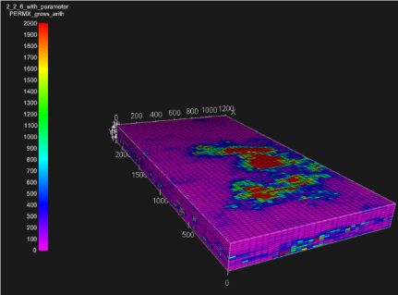 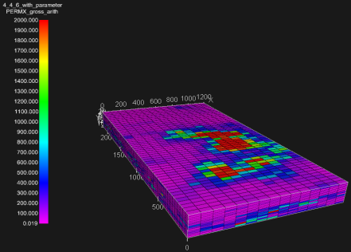 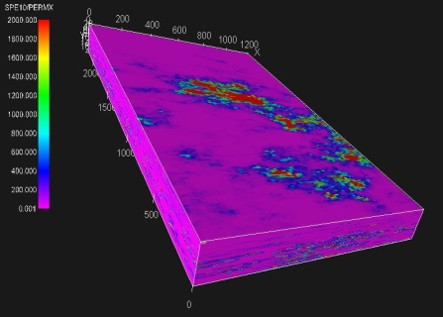

2 by 2 by 6 4 by 4 by 6 fine scale

## Permeability Kz

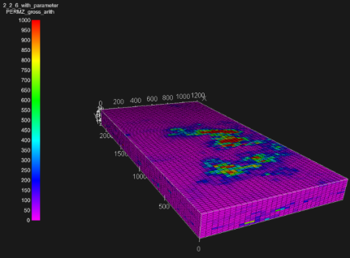 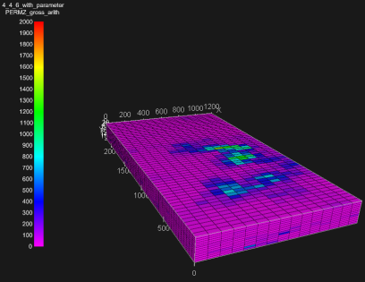 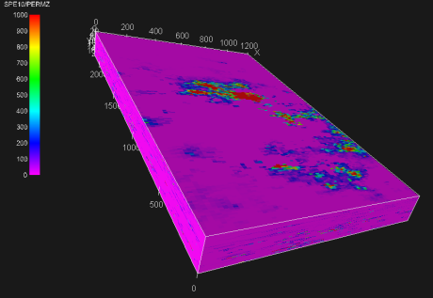

2 by 2 by 6 4 by 4 by 6 fine scale

## Porosity

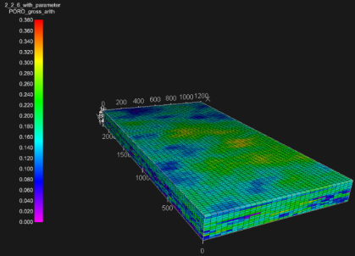 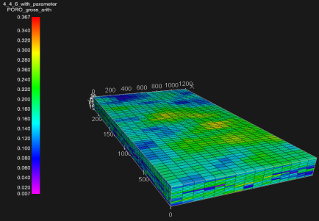 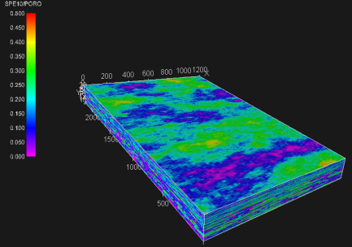

2 by 2 by 6 4 by 4 by 6 fine scale

## Harmonic

## Permeability Kx

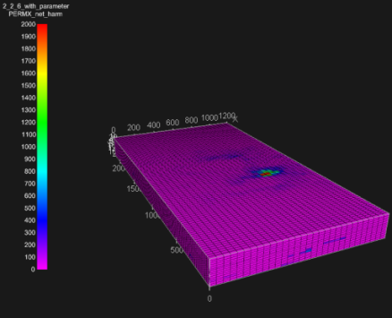 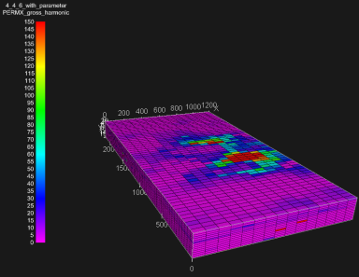 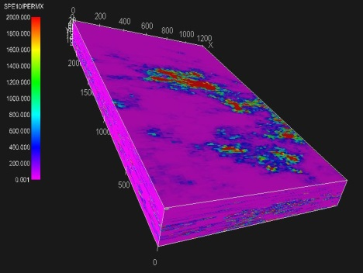

2 by 2 by 6 4 by 4 by 6 fine scale

## Permeability Kz

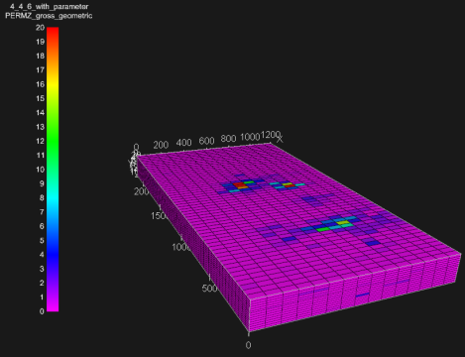 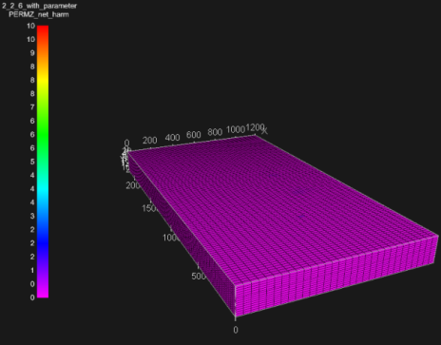 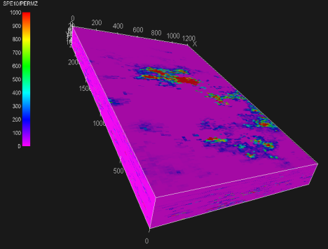

2 by 2 by 6 4 by 4 by 6 fine scale

## Geometric

## Permeability Kx

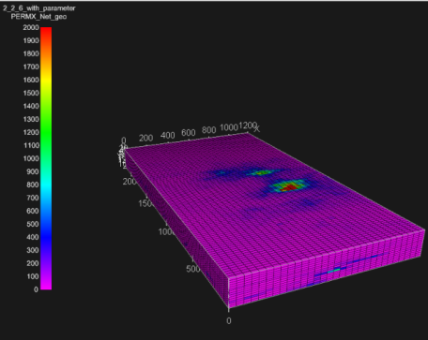 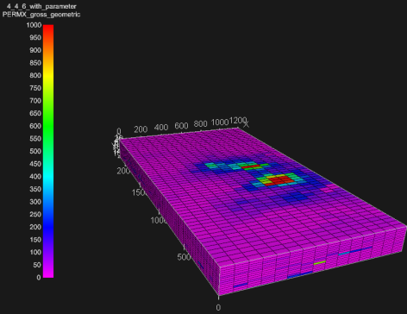 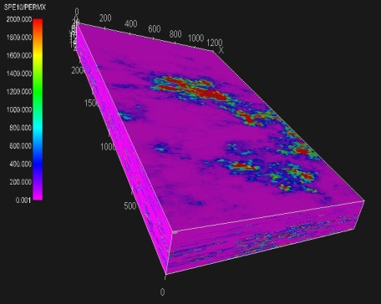

2 by 2 by 6 4 by 4 by 6 fine scale

## Permeability Kz

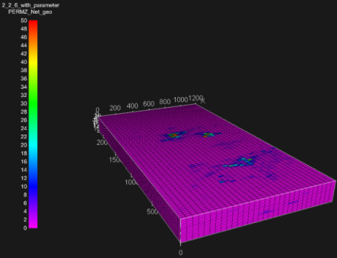 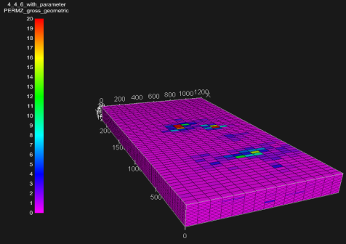 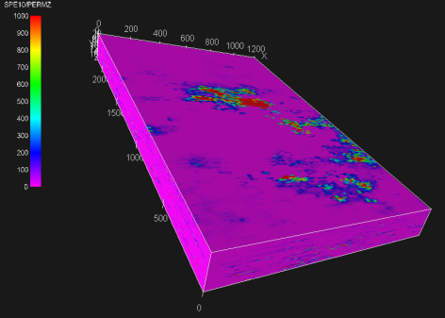

1. by 2 by 6 4 by 4 by 6 fine scale

## Arithmetic-Harmonic “Take the arithmetic average in each slice perpendicular to the x-direction, followed by the harmonic average across these slices.”

## Permeability Kx

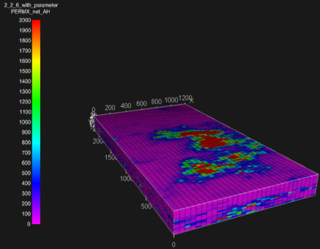 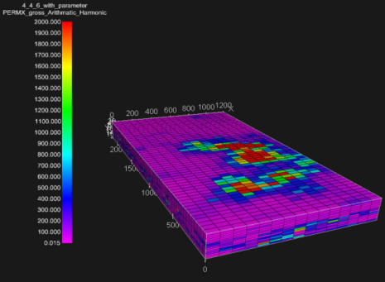 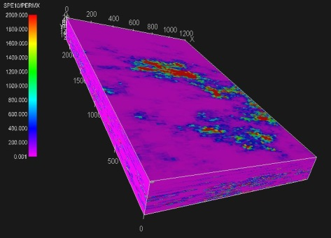

2 by 2 by 6 4 by 4 by 6 fine scale

## Permeability Kz

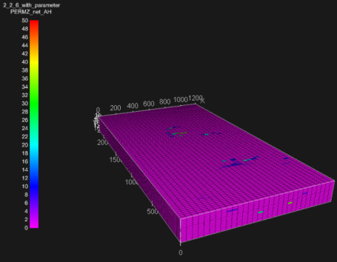 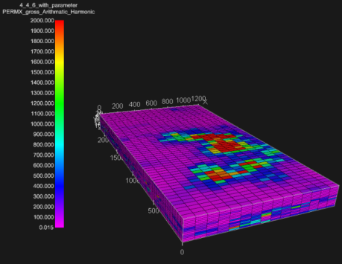 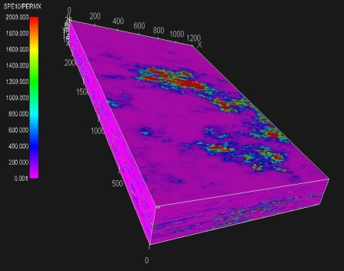

2 by 2 by 6 4 by 4 by 6 fine scale

## Harmonic-Arithmetic “Take the harmonic average along a horizontal "tube" in the x-direction, followed by the arithmetic average across these tubes.”

## Permeability Kx

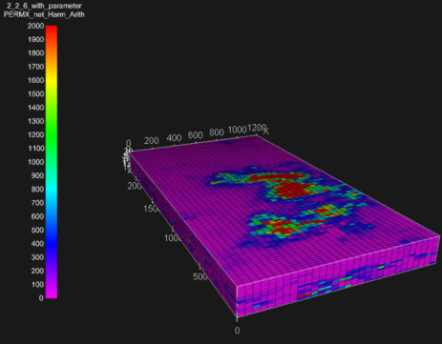 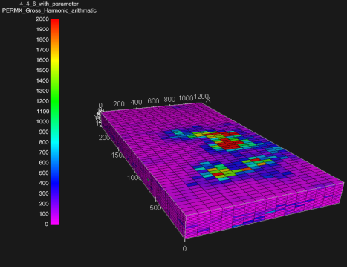 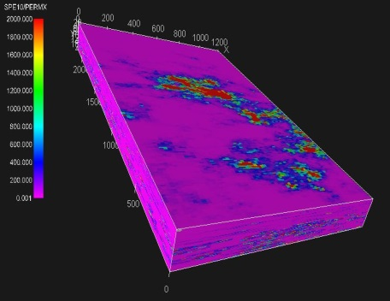

2 by 2 by 6 4 by 4 by 6 fine scale

## Permeability Kz

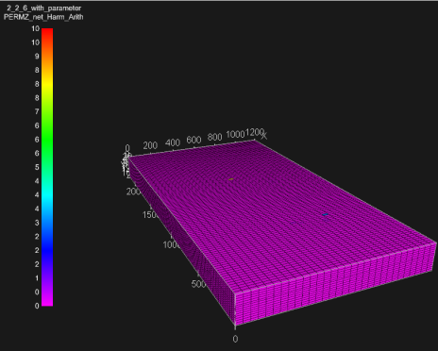 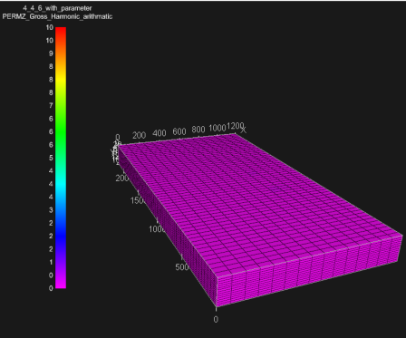 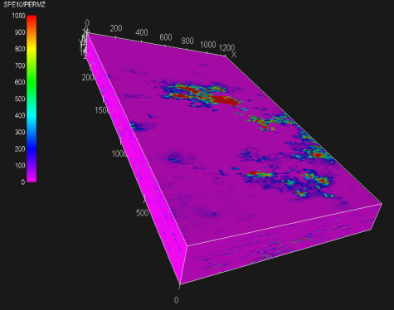

2 by 2 by 6 4 by 4 by 6 fine scale

## Well Index Upscaling

## Permeability Kx

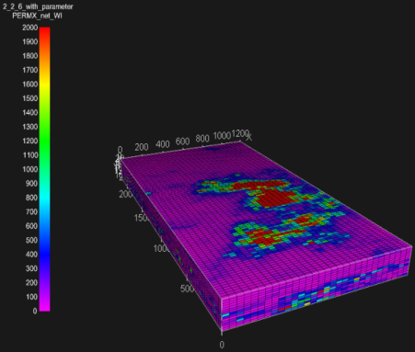 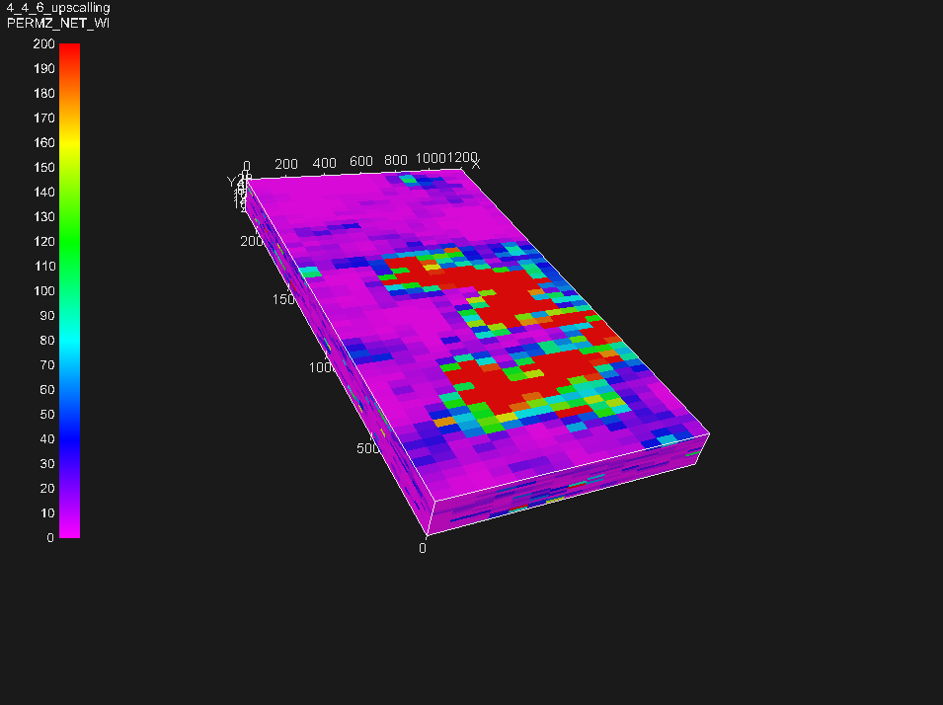 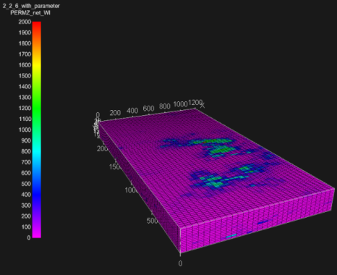

2 by 2 by 6 4 by 4 by 6 fine scale

## Permeability Kz

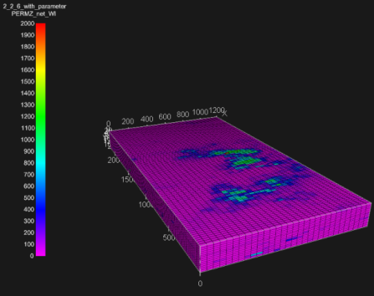 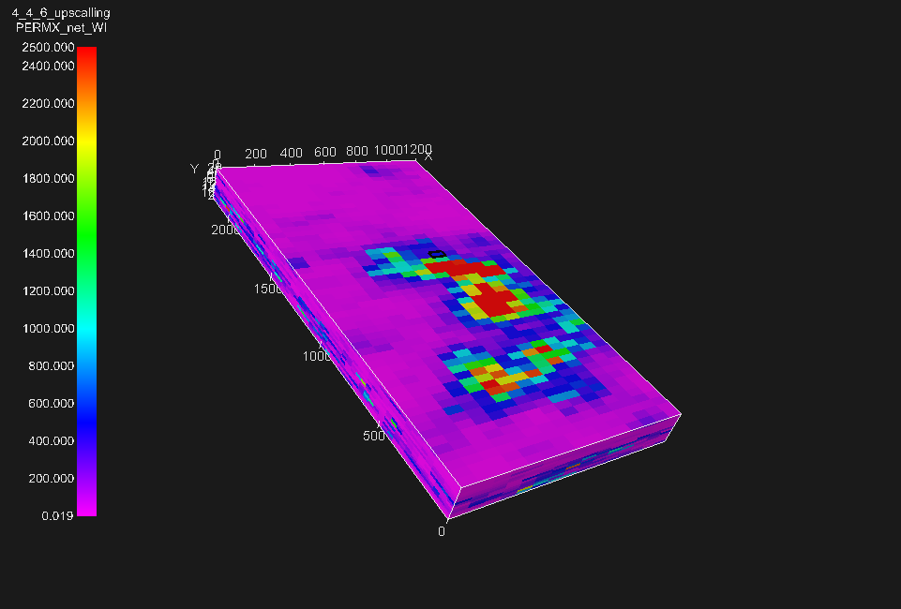 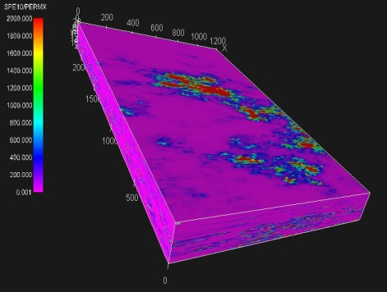

1. by 2 by 6 4 by 4 by 6 fine scale

## Summary

|  |  |  |  |  |  |  |
| --- | --- | --- | --- | --- | --- | --- |
| 1. 2*2*6 Gross | Arithmetic | Harmonic | Geometric | Arithmetic-Harmonic | Homornic-Arithmetic | Well Index |
| Kx,md | 364.41 | 32.58 | 82.53 | 340.88 | 237.14 | 364.42 |
| Ky,md | 364.41 | 32.58 | 82.53 | 340.88 | 237.14 | 364.42 |
| Kz,md | 58.74 | 0.26 | 1.65 | 1.28 | 0.60 | 47.74 |
| Porosity | 0.172 | NA | NA | NA | NA | NA |
|  |  |  |  |  |  |  |
|  |  |  |  |  |  |  |
| 2*2*6 Net | Arithmetic | Harmonic | Geometric | Arithmetic-Harmonic | Homornic-Arithmetic | Well Index |
| Kx,md | 368.78 | 33 | 86.6 | 344.47 | 237.67 | 368.78 |
| Ky,md | 368.78 | 33 | 86.6 | 344.47 | 237.67 | 368.78 |
| Kz,md | 59.18 | 0.26 | 1.66 | 1.28 | 0.2 | 48.05 |
| Porosity | 0.175 | NA | NA | NA | NA | NA |
|  |  |  |  |  |  |  |
|  |  |  |  |  |  |  |
| 4*4*6 Gross | Arithmetic | Harmonic | Geometric | Arithmetic-Harmonic | Homornic-Arithmetic | Well Index |
| Kx,md | 364.42 | 21.2 | 66.3 | 319.05 | 135.9 | 364.42 |
| Ky,md | 364.42 | 21.2 | 66.3 | 319.05 | 135.9 | 364.42 |
| Kz,md | 58.74 | 0.005 | 1 | 2.82 | 0.11 | 45.66 |
| Porosity | 0.172 | NA | NA | NA | NA | NA |
|  |  |  |  |  |  |  |
|  |  |  |  |  |  |  |
|  |  |  |  |  |  |  |
|  |  |  |  |  |  |  |
| 4*4*6 Net | Arithmetic | Harmonic | Geometric | Arithmetic-Harmonic | Homornic-Arithmetic | Well Index |
| Kx,md | 368.98 | 21.73 | 74.64 | 322.56 | 136.54 | 368.98 |
| Ky,md | 368.98 | 21.73 | 74.64 | 322.56 | 136.54 | 368.98 |
| Kz,md | 59.21 | 0.005 | 1.02 | 2.83 | 0.07 | 45.95 |
| Porosity | 0.175 | NA | NA | NA | NA | NA |

The table above shows the properties (horizontal permeability, vertical permeability and porosity) upscaled by different methods in different cases (2*2*6 and 4*4*6).

We can observe that in the 4 cases, arithmetic average upscaling and well-index upscaling give the highest results for horizontal permeability, while harmonic average upscaling gives the lowest results.

Comparing the gross upscaling method in 2*2*6 and 4*4*6 cases, we can see that:

For kx: Arithmetic=Well Index>Arithmetic-Harmonic> Harmonic-Arithmetic>Geometric>Harmonic   
For kz in 2*2*6 case: Arithmetic>Well Index > Geometric> Arithmetic-Harmonic> Harmonic-Arithmetic> Harmonic

For kz in 4*4*6 case: Arithmetic>Well Index > Arithmetic-Harmonic > Geometric > Harmonic-Arithmetic> Harmonic

# Flow based Upscaling

Flow based Upscaling Methods

1) Permeability Upscaling

2) Transmissibility Upscaling

3) Wide Boundary Conditions

4) Diffuse Source

# 6.1 Permeability based flow based Upscaling

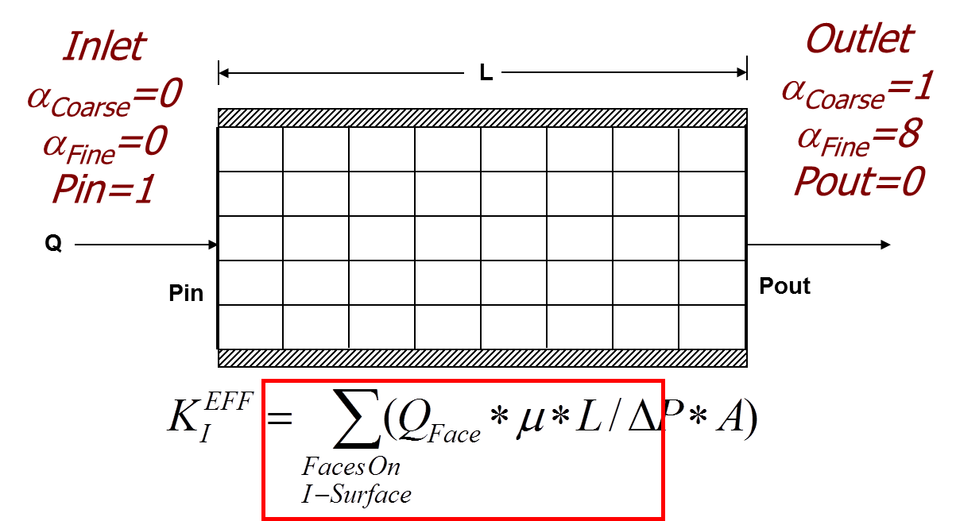

The above diagram shows the method to upscale permeability using flow based methods.

Steps

* Select a coarse block as per the coarsening ratio of the upscaling
* The coarse block will have no flow boundaries on all side except for the side in which the upscaled permeability has to be calculated
* The above diagram shows a calculation of permeability in the X-direction. So , we have imposed a constant pressure of 1 psi on the left and 0 psi on the right.
* A local pressure solve is done on this coarse block .
* The pressures at the centres of the fine cells are calculated.
* The flux entering the block =The flux leaving the block(Incompressible flow). The flux entering the block can be calculated by using the difference of pressures of the leftmost fine cells and left boundary pressure of 1 psi.
* The upscaled permeability is calculated by using Darcy’s law and treating the whole coarse block a s a single cell across which a pressure difference of 1 psi has been applied.

Key points

* In our model we have a discontinuity at between layer 35 and layer 36. So in a 1:6 upscaling in the Z-direction we will have the layers 31-35 merged into a single layer because we won’t upscale across the geological discontinuity.
* Layers 84-85 have to be merged into a single layer.
* All other layers will follow the 1:6 upscaling ratio.
* The transmissibilities for the leftmost and rightmost cells for the above case will be half cell transmissibilities.

**2x2x6 permeability upscaling results**

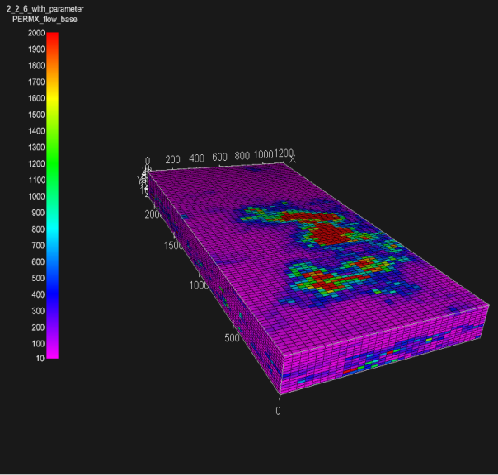 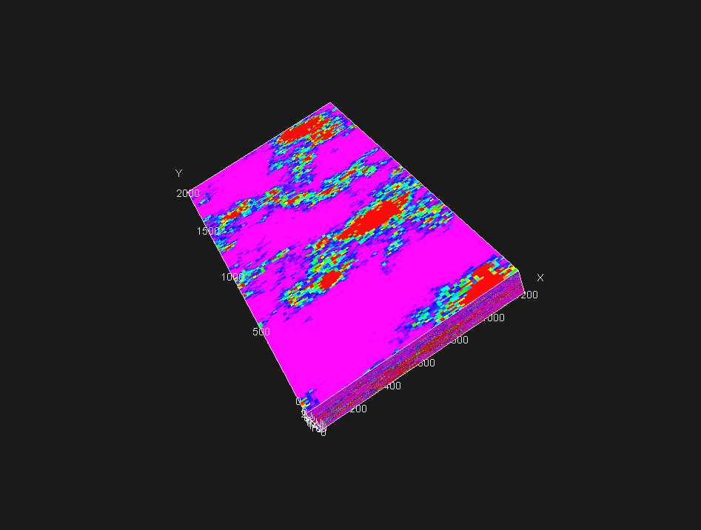

Kx(coarse) Kx(fine)

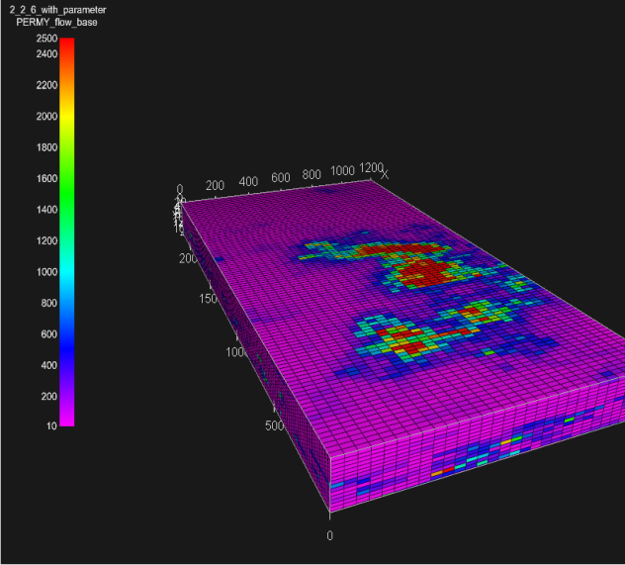 

Ky(coarse) Ky(fine)

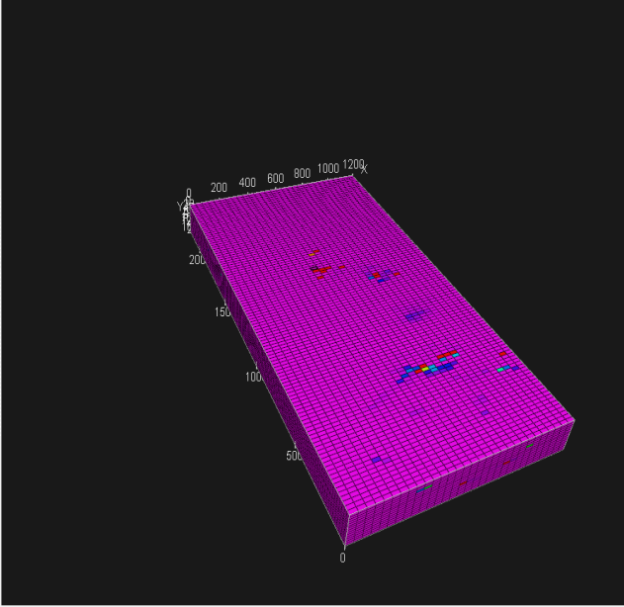 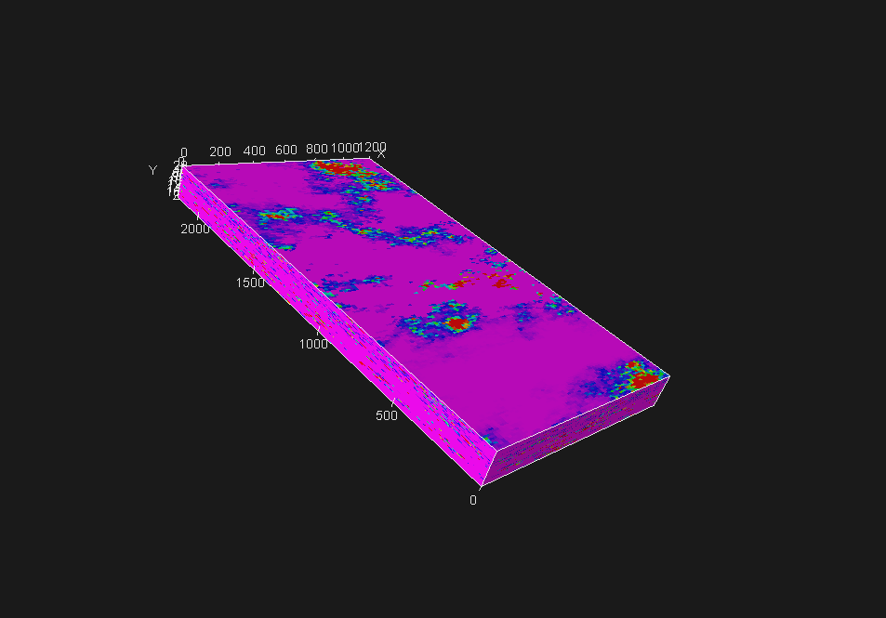

Kz(coarse) Kz(fine)

The heterogeneity is completely lost in the Kz upscaling. This is due to the fact that flow based upscaling captures the lows of permeability and is a kind of harmonic averaging.

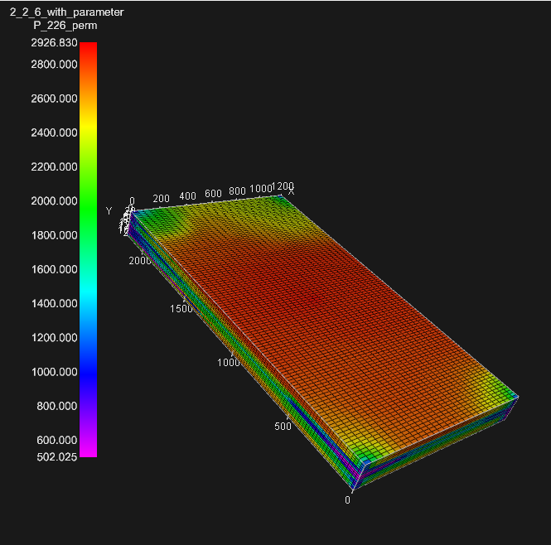 

Pressure (coarse) Pressure (fine)





Mean=108.42 psi

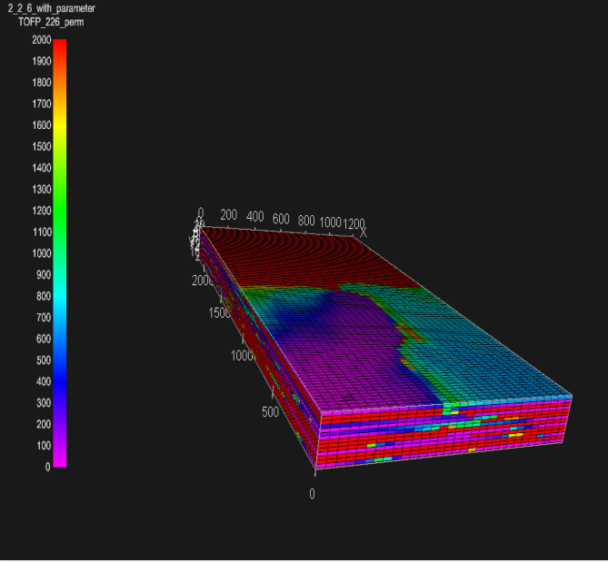 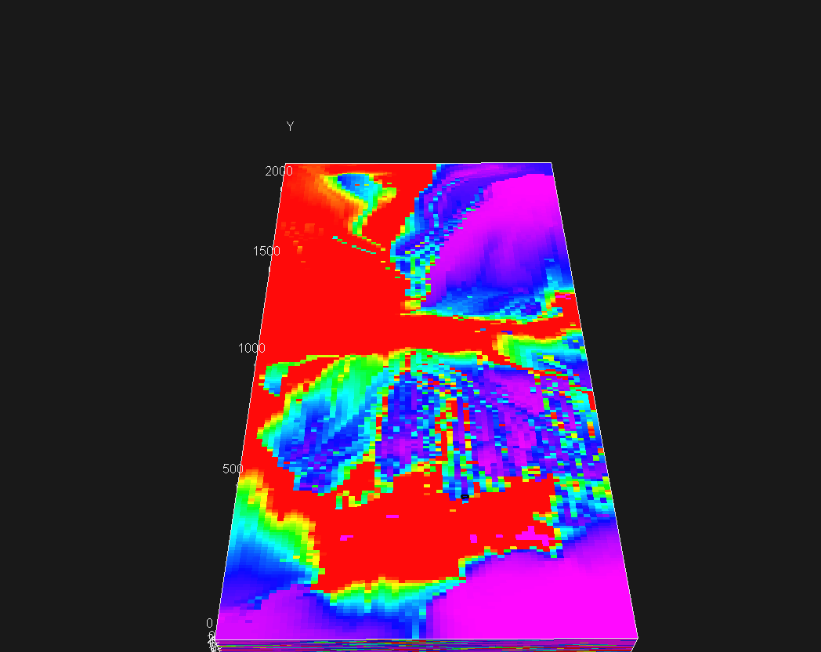

TOFP(coarse scale) TOFP(fine scale)

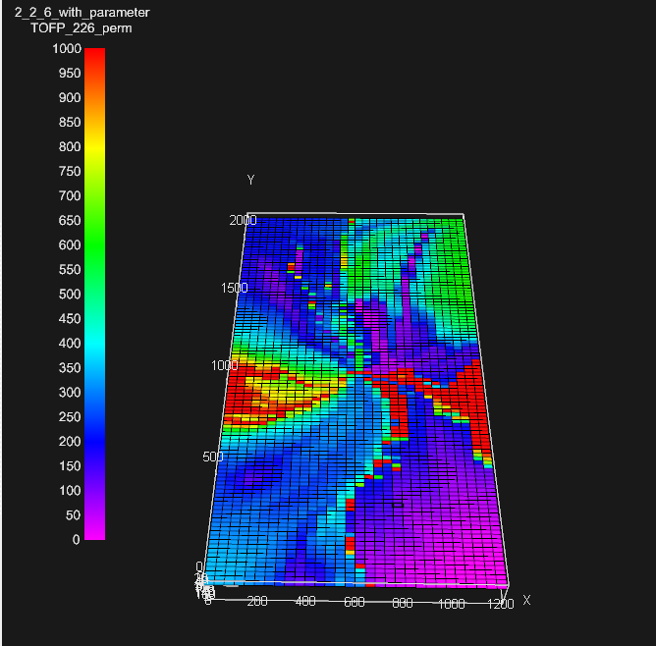 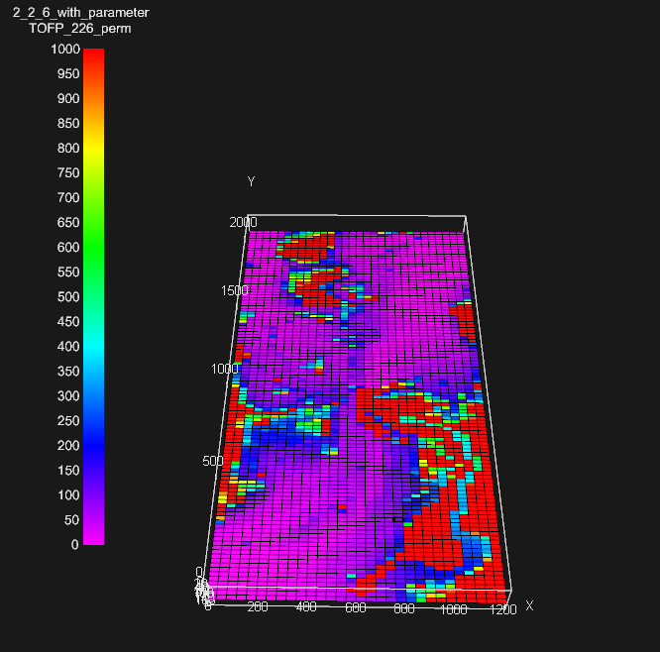

TOFP Layer-4(submarine fan) TOFP Layer-11(channel)

**4x4x6 permeability upscaling**

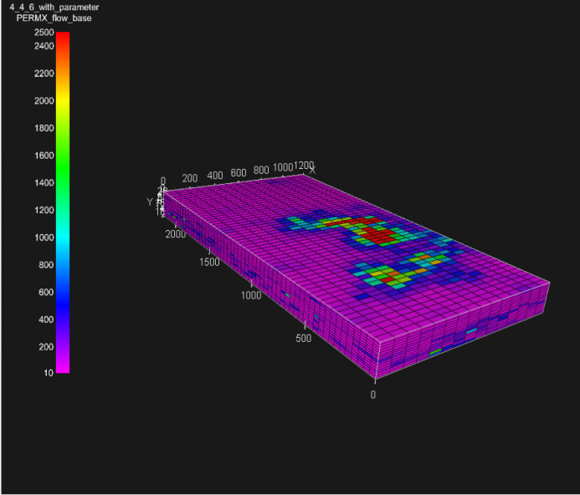 

Kx(coarse) Kx(fine)

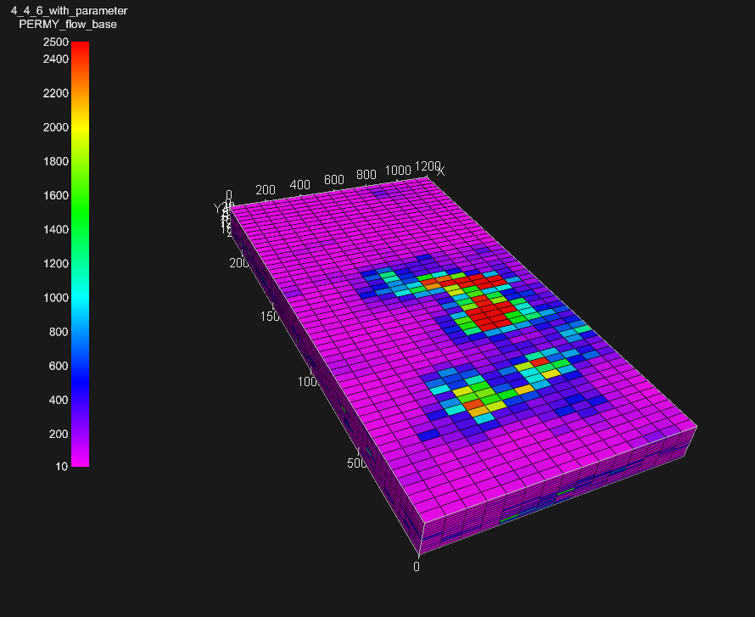 

Ky(coarse) Ky(Fine)

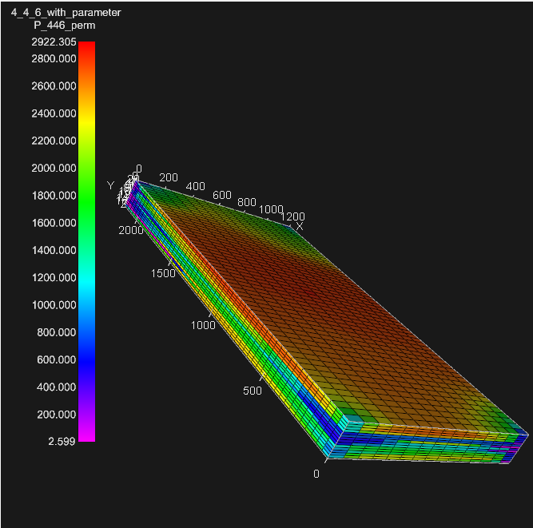 

Pressure(coarse) Pressure(fine)





Mean=358.4912 psi

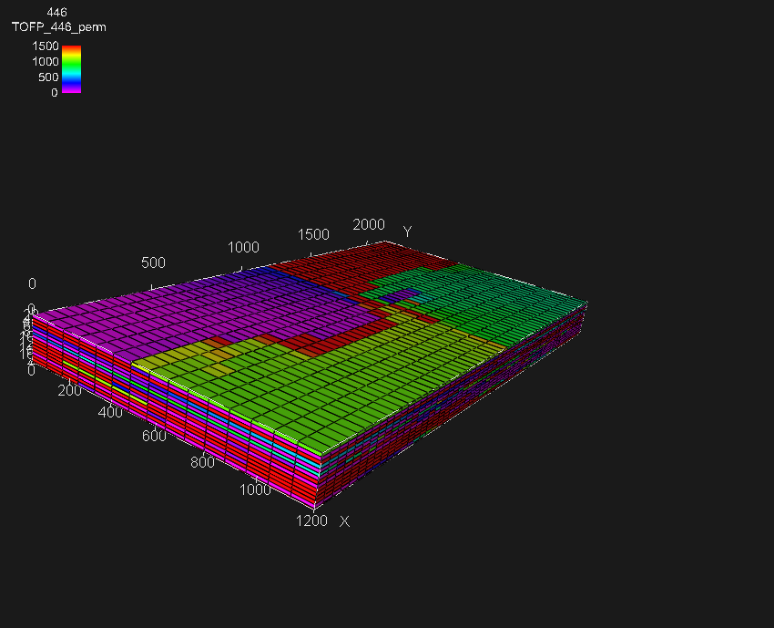 

TOFP(coarse) TOFP(fine)

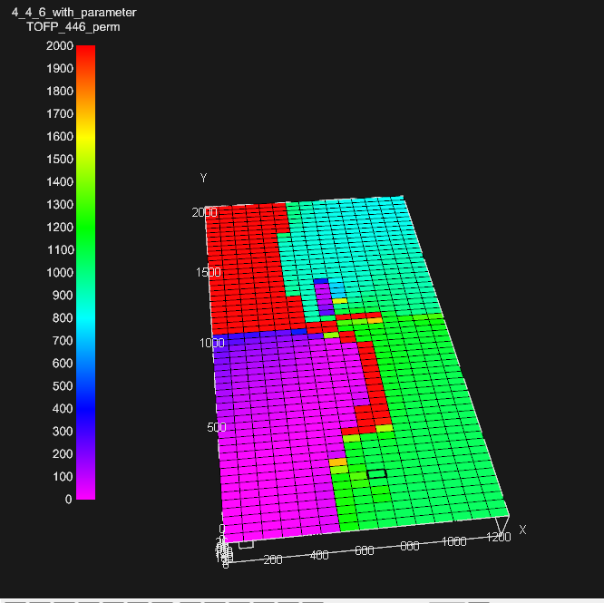 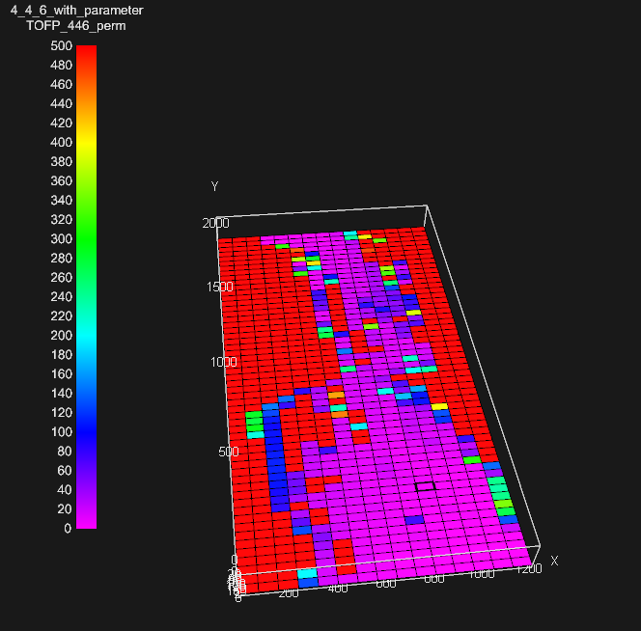

TOFP Layer-1(submarine fan) TOFP Layer-14(channel)

# 6.2 Transmissibility based flow based Upscaling

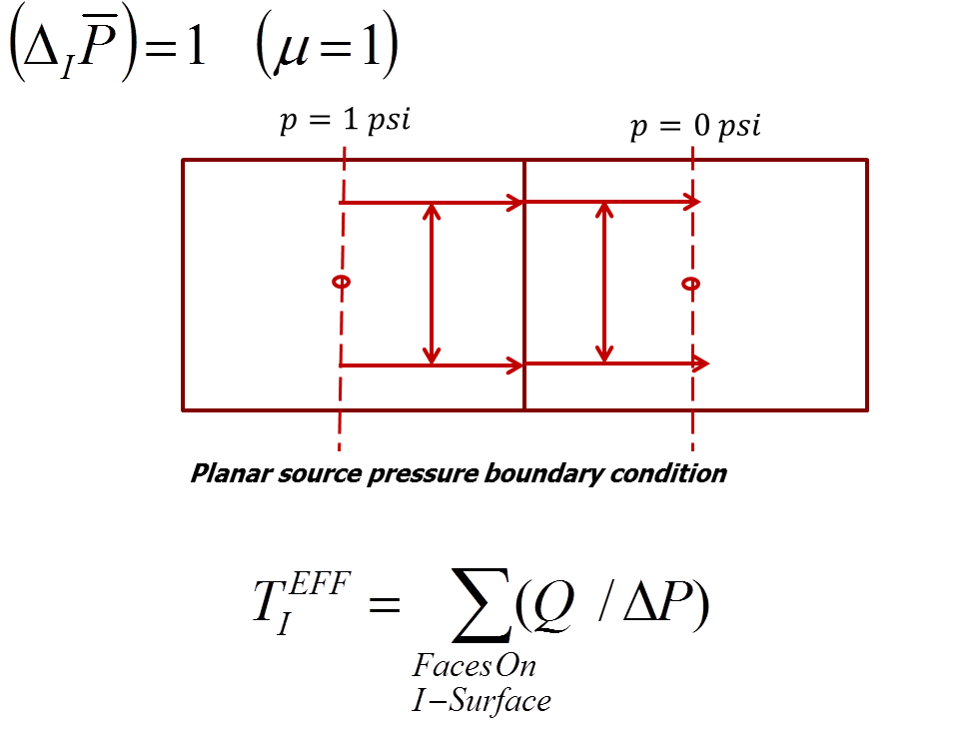

Steps

* Two coarse blocks are selected side by side.
* A planar pressure boundary is placed at the middle of each coarse block.
* All the side except in which transmissibility is to be upscaled are closed and are considered as no flow boundaries
* In the above diagram, upscaling is being done in the X-direction. A pressure of 1 psi is kept on the left side in the middle of the left coarse cell and a pressure of 0 psi in the middleof the right coarse cell.
* A local pressure solve is done in this block and the pressures at the centre of the fine cells are calculated
* The net flux entering the coarse block is calculated next using Darcy’s law.
* Then the effective upscaled transmissibility is calculated using the the correlation show above in the figure.

Key points

* In a 1:6 coarsening ratio in the Z-direction, the sixth coarse layer will have 31-35 fine layers and the seventh coarse layer will have 36-41 fine layers. For upscaling the transmissibility across these two blocks we will have a 5 layer and a 6 layer block. For the 5 layer block, we will have a pressure boundary at the middle of the 3rd fine cell. Half of the fine cell will be considered a cell in our local pressure solve
* Half Cell Transmissibilities for these half fine cells need to changed accordingly.
* In a 1:12 coarsening ratio in the Z-direction, the 3rd coarse layer will have 11 fine layers and the 4th coarse layer will have 12 fine layers. We wil follow the same procedure as mentioned previously.

**2x2x6 transmissibility upscaling**

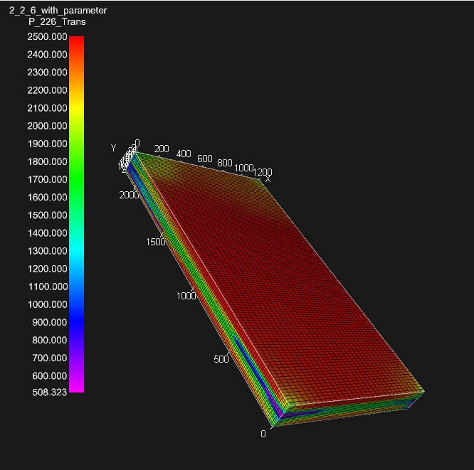 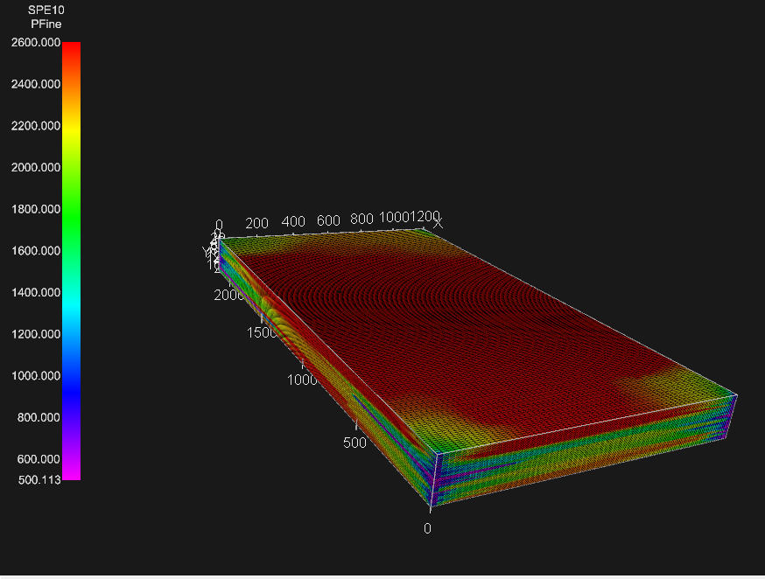

Pressure(coarse) Pressure(fine)





Mean=249.0786 psi

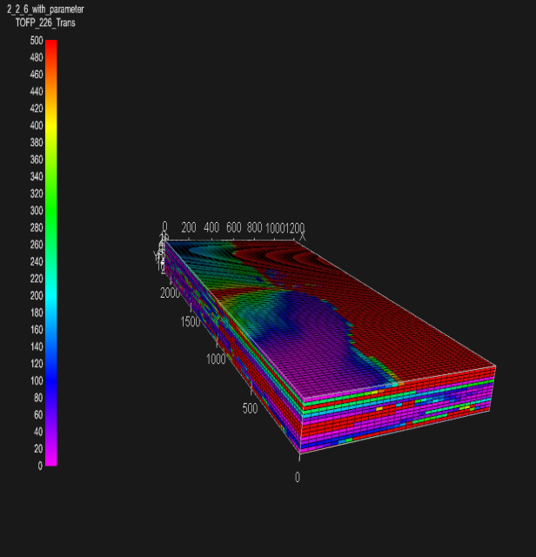 

TOFP(coarse) TOFP(fine)

**Areal pattern preserved**

**2x2x12 transmissibility upscaling**

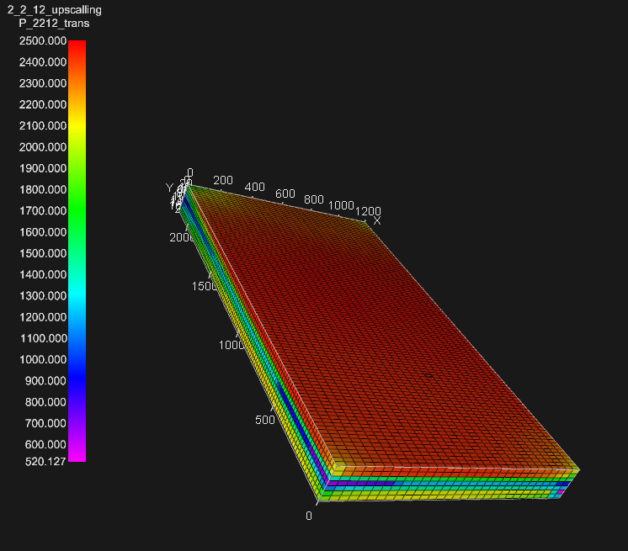 

Pressure(coarse) Pressure(fine)

Heterogeneity lost in the coarse model





Mean=393.36 psi

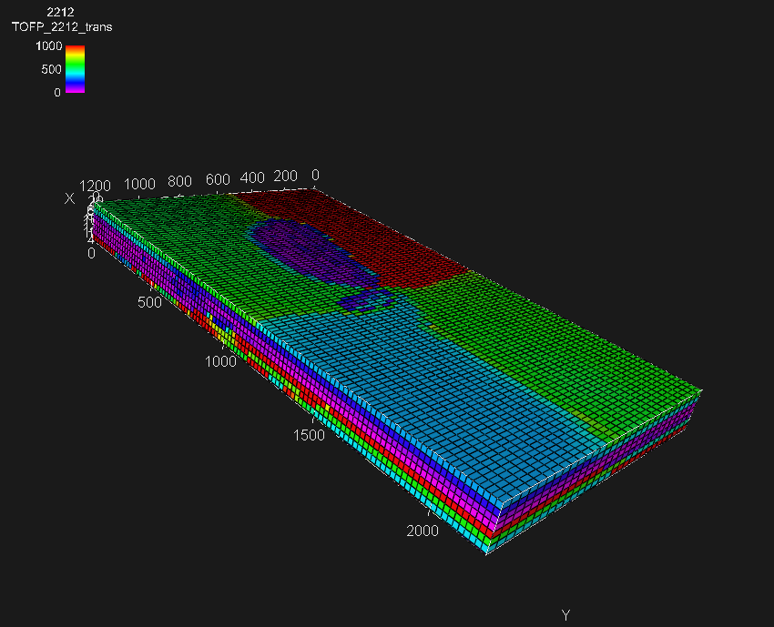 

TOFP(coarse model) TOFP(fine)

**All heterogeneity lost**

# Computational times

# Conclusions

* 2x2x6 Perm Upscaling gives the closest Pressure Match but TOFP is not representative
* 2x2x6 gives representative TOFP but layer coarsening needs to be reduced to produce more accurate results
* 2x2x2 trans Upscaling would be a better solution for this problem.